Hospital at Home Command Center 732-375-4891

HUMC Hospital at Home Program FAQs for EMS

Q. Who is eligible for Hospital at Home?

- Under the CMS Acute Hospital Care at Home waiver program, patients with fee-for-service Medicare and participating Medicare Advantage programs can be considered for the program. Based on the patient's inpatient diagnosis, our clinical team will evaluate both the patient's clinical status as well as their home social stability status to determine if they are a candidate for Hospital at Home. Under this waiver program, Hospital at Home patients are HUMC inpatients and will be managed by the HUMC Hospitalist physicians.

Q. How is a Hospital at Home patient registered in HUMC?

- Hospital at Home patients appear in Epic as any other admitted inpatient. They are admitted to a virtual inpatient unit. Hospital at Home is not available to patients in observation status.

Q. What is the protocol for a Hospital at Home patient to connect with EMS in the case of an escalation back to the hospital?

- There is a 24/7 Hospital at Home Command Center based out of the JFK University Medical Center EMS Dispatch and Communication Center. Patients are advised to contact the Hospital at Home Command Center phone number 732-375-4891 with any concerns or emergencies.The patient will be triaged by an RN who will contact the appropriate resource based on the patient’s clinical condition. If the RN feels that the patient can continue to be managed in the home, the Command Center RN will contact the attending physician. If the Command Center RN feels that a 9-1-1 response is appropriate, the RN will notify MICCOM to ensure the appropriate 9-1-1 resource(s) are dispatched. MICCOM will notify the local EMS agency if a MICCOM unit is not the designated BLS service provider.

Q. How would EMS identify a patient as a Hospital at Home patient?

- Hospital at Home patients will be wearing an HMH hospital ID band with an orange colored sticker that says Hospital at Home.

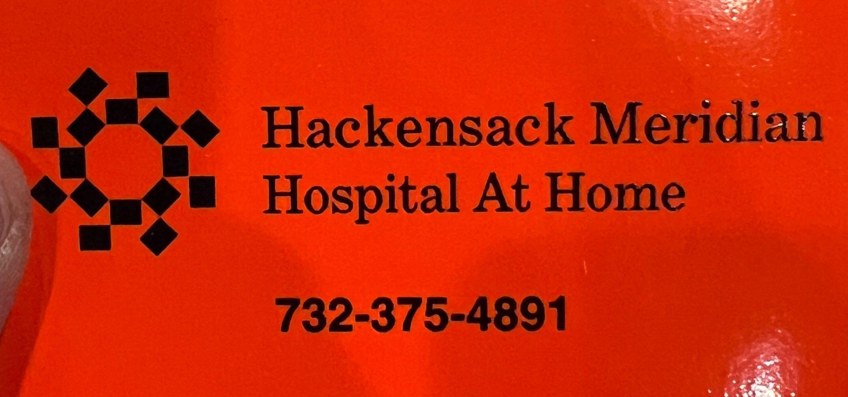

Q. What should you do if you arrive at a home and determine the patient belongs to the Hospital at Home program?

- You should call the Hospital at Home Command Center at 732-375-4891 (the number will also be on the patient’s ID band). This will ensure a smooth transition to the ED. The Command Center RN will discuss the patient’s current clinical condition with the caller to determine whether or not the patient should be transported to Hackensack University Medical Center.

Q. What geographic area is covered by the HUMC Hospital at Home program?

- The CMS waiver requires a 30 minute response time therefore the program is limited to certain towns in Bergen County.

Q. If a patient is transported to the hospital by EMS while in the Hospital at Home program, how does this affect claim submission to Medicare for EMS transports?

- EMS should follow all standard billing procedures. If a claim is denied, please contact Steve Wilenchik at HUMC EMS (steven.wilenchik@hmhn.org) for assistance with EMS billing issues.

Q. Will the Hospital at Home program at any time cross paths with ET3?

- No. Although both programs use telemedicine, if a patient is in the Hospital at Home program, telemedicine will be provided by the Hospital at Home physician, not the ET3 telemedicine provider. If EMS is called to assist a Hospital at Home patient, the first call should be to the Hospital at Home Command Center nurse.

Q. In the event of a true medical emergency, does EMS still need to call the Hospital at Home Command Center?

- Yes. In order to ensure the patient can be registered in the HUMC Emergency and Trauma Center, the Hospital at Home Command Center must be notified as soon as the patient is known to be a Hospital at Home patient.

